**9. EKS Cluster Pricing Note - Very Important**

--- Reference - <https://github.com/stacksimplify/aws-eks-kubernetes-masterclass/tree/master/01-EKS-Create-Cluster-using-eksctl>

--- [aws-eks-kubernetes-masterclass](https://github.com/stacksimplify/aws-eks-kubernetes-masterclass)/**01-EKS-Create-Cluster-using-eksctl**/

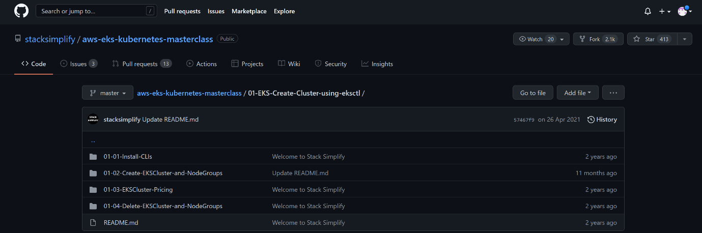

--- click on the EKSCluster-Pricing

--- <https://github.com/stacksimplify/aws-eks-kubernetes-masterclass/tree/master/01-EKS-Create-Cluster-using-eksctl/01-03-EKSCluster-Pricing> - you can see the pricing details here.